|  |  |  |  |
| --- | --- | --- | --- |
|  | |  |  | | --- | --- | |  | **Eastern Goldfields College**  ***Year 12 MATHEMATICS METHODS***  ***TEST 3 2017***  ***Calculator Free*** |   **Name:** |

**Total Marks: 33**

**Reading: 2 minutes Time Allowed: 35 minutes**

Question 1 (9 marks)

(a) Solve . (1 mark)

(b) Rearrange the equation  for . (2 marks)

(c) Solve . (3 marks)

(d) If  and , express the following in terms of  and :

(i)  (1 mark)

(ii)  (2 marks)

Question 2 (11 marks)

Differentiate the following, simplifying where possible.

(a)  (2 marks)

(b)  (3 marks)

c)  (4 marks)

d)  (2 marks)

Question 3 (5 marks)

(a) Sketch  on the following semi-log paper. (2)

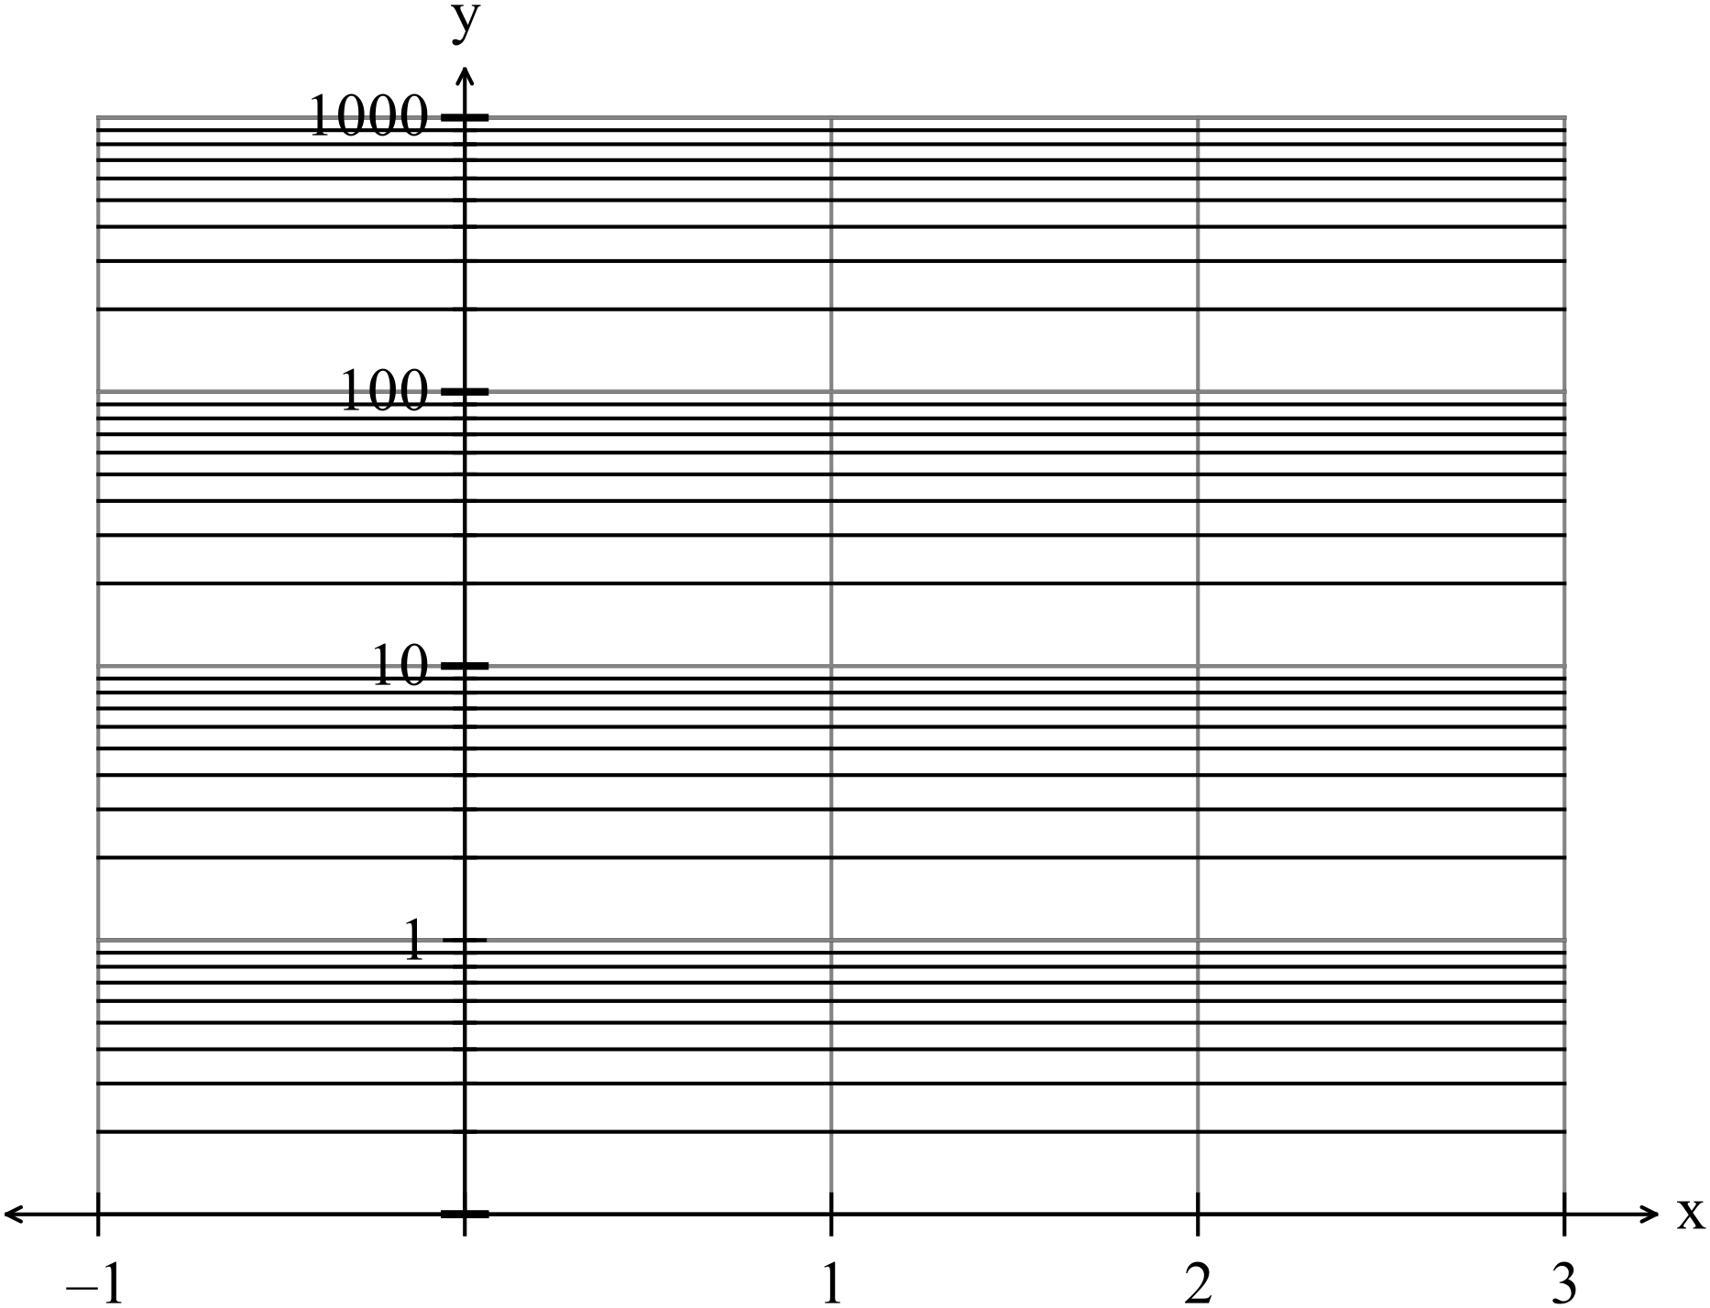

(b) (i) Find the derivative of  (2)

(ii) hence determine  (1)

**Question 4 (8 marks)**

1. Evaluate the following

 (3)

(b) Determine [3]



$$\int{\frac{x+1}{3x^{2}+6x+3}}dx$$

(c) *Hence*, or otherwise evaluate : $$\int_{0}^{1}{\frac{x+1}{3x^{2}+6x+3}}dx$$***exactly.*** [2]

|  |  |  |  |
| --- | --- | --- | --- |
|  | |  |  | | --- | --- | |  | **Eastern Goldfields College**  **Year 12 MATHEMATICS METHODS**  **TEST 3 2017**  **Calculator Assumed** |   **Name:** |

**Total Marks: 23**

**Reading: 2 minutes Time Allowed: 25 minutes**

**Question 5 (7 marks)**

(a) The graph of  is shown on the set of axes below,

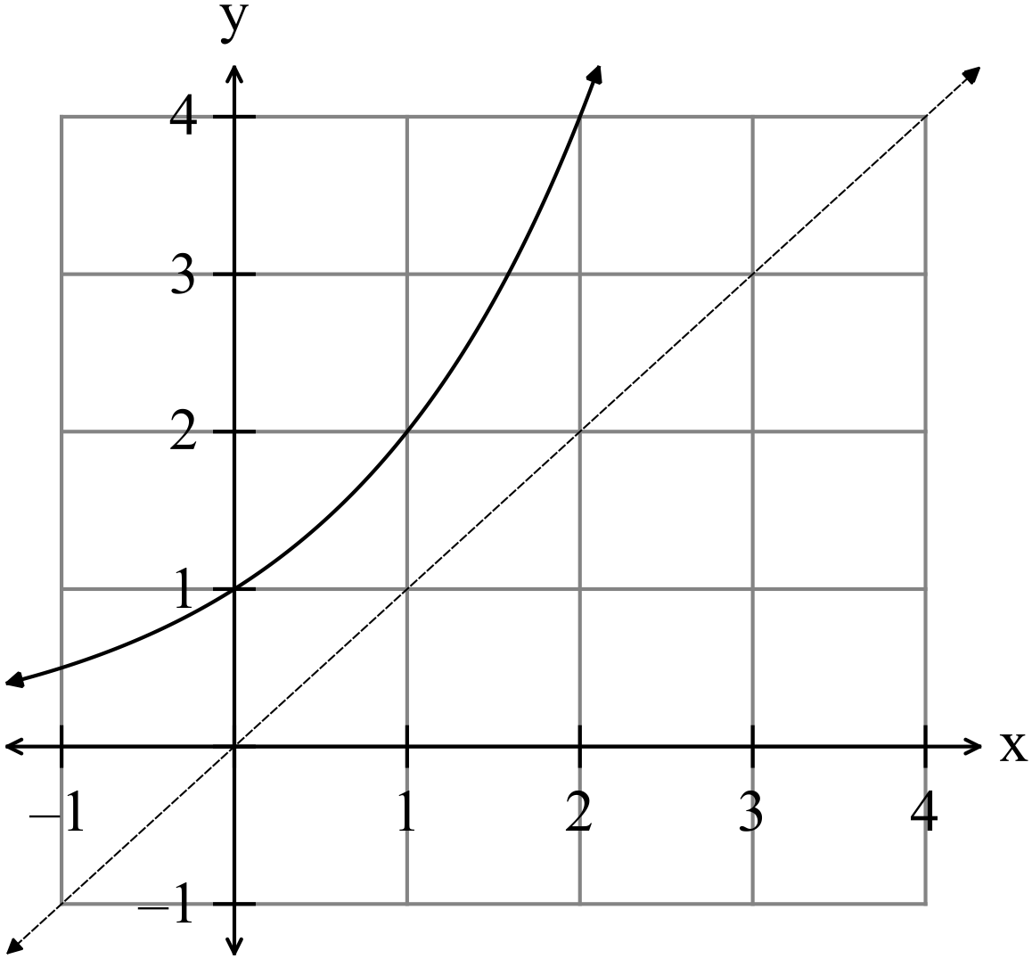

Sketch on the same set of axes

(i) , the inverse of the function. (2)

(ii)  (3)

(iii) . (2)

**Question 6 (7 marks)**

(a) Use your calculator to find the area enclosed between the two functions

 and  as shown in the diagram below.

The points of intersection are shown.

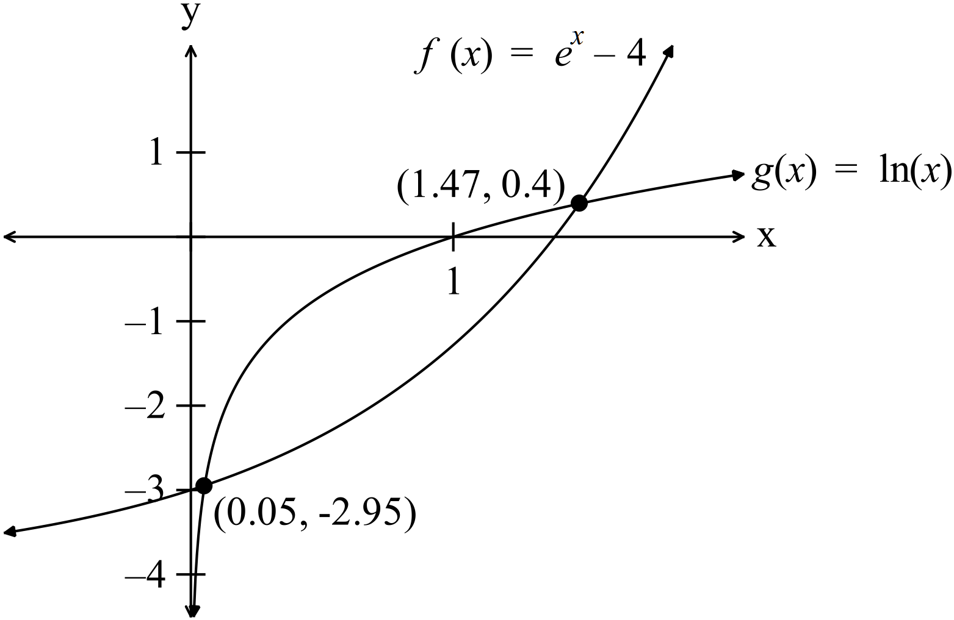 (3)

(b) A small colony of quolls live in hummock grasslands on the sand plains not far

from Port Hedland. The population of this colony was studied in 2002. The

population can be modelled by the equation  whereis in

years starting in 2002.

(i) What was the population in 2002? (2)

(ii) In what year will the population reach 100? (2)

**Question 7 (9 marks)**

(a) Simplify each of the following by expressing each as a single logarithmic term.

(i)  [2]

(ii)  [2]

(b) If  then find in terms of *c*, *g* and *j*.

(i)  [1]

(ii)  [2]

(iii)  [2]